Not able to deploy Virtual Machines or Virtual Machine Scale Sets (Uniform) with Capacity Reservation

If you have an existing Capacity Reservations that you are not able to use with Virtual Machines or Virtual Machine Scale Sets, it could be because of any of the reasons below:

- Limitations and Restrictions of Capacity Reservation
  - Not all deployment constraints are currently supported. Some of the constraints are:
    - Proximity Placement Group
    - Update domains
    - UltraSSD storage
  - Spot VMs and Azure Dedicated Host Nodes are not supported with capacity reservation.
  - For the supported VM series during public preview, up to 3 Fault Domains (FDs) will be supported. A deployment with more than 3 FDs will fail to deploy against capacity reservation.
  - Availability Sets are not supported with capacity reservation.
  - The scope for capacity reservation is subscription i.e., only the subscription that created the reservation can use it. So, if your VM/VMSS is in a different subscription, please create a new reservation in that subscription or create your VM/VMSS in the subscription that already has access to the capacity reservation.

- Not deploying explicitly against the reservation
In order to consume Capacity Reservation, it should be explicitly added as a property of the Virtual Machine or Virtual Machine Scale Sets. Please refer to the documentation below to learn more about how to do that:

- Click here to learn more about how to associate a new Virtual Machine to Capacity Reservation
- Click here to learn more about how to associate a new Virtual Machine Scale Sets to Capacity Reservation

- Trying to attach running VM/VMSS without deallocating them first
In order to attach running VM/VMSS to Capacity Reservation, they need to be deallocated first and then at the time of reallocation, reference Capacity Reservation as a property of the VM/VMSS.

Not able to create Capacity Reservation

Following are some of the reasons why you are not able to create capacity reservation:

- Lack of capacity in the Region/Availability Zone
Azure doesn't have capacity for the combination of requested VM size/location/Qty. In this case, either retry after some time as new capacity might become available or try a different combination of VM size/location/Qty.
Please note that Capacity Reservation creation succeeds or fails in its entirety. For a request to reserve 10 instances, success is returned only if all 10 could be allocated. Otherwise, the capacity reservation creation will fail.

- Unsupported VM size
Not all VM sizes are supported with Capacity Reservation. During Public Preview, we support only Av2, B, D, E, & F VM series. Support for other VM series is in progress and will be announced when available.

- Subscription doesn't have the required quota
Restricted by quota: Creating capacity reservations requires quota in the same manner as it does for creating virtual machines. If you get insufficient quota error while creating capacity reservation, please request additional quota by clicking here or try a different combination of VM size/location/Qty.

- Don’t have access to create reservation
Reservations are only available to paid Azure customers. Sponsored accounts such as Free Trial and Azure for Students are not eligible to use this feature. In order to create a new paid Azure subscription, please click here.

Steps to create Capacity Reservation

Create a Capacity Reservation in Azure (preview) - Azure Virtual Machines | Microsoft Docs

Not able to delete Capacity Reservation or Group

Capacity Reservations can be deleted only when no Virtual Machines or Virtual Machine Scale Sets are associated to the group.

Click here for detailed steps on how to delete capacity reservation.

Azure will only allow a Capacity Reservation Group to be deleted when all member Capacity Reservations.

Billing related question for Capacity Reservation
Capacity Reservations are priced at the same rate as the underlying VM size. For example, if a customer creates a reservation for 10 quantities of D2s_v3 VM, as soon as the reservation is created, they start getting billed for 10 D2s_v3 VMs irrespective of whether the reservation is being used or not.
If the customer then deploys a D2s_v3 VM and specifies reservation as its property, the capacity reservation gets used. Once in use, customer pays only for the VM and nothing extra for the capacity reservation. For instance, let’s say a customer deploys 5 D2s_v3 VMs against the aforementioned capacity reservation. In this case, they will see a bill for 5 D2s_v3 VMs and 5 unused capacity reservation, both charged at the same rate as a D2s_v3 VM.
Both used and unused capacity reservation are eligible for Reserved Instances term commitment discounts. In the above example, if the customer has Reserved Instances for 2 D2s_v3 VM in the same Azure region, the billing for 2 resources (either VM or unused capacity reservation), will be zeroed out as it’s already been paid through Reserved Instances and the customer will only pay for rest of the 8 resources i.e., 5 unused capacity reservations and 3 D2s_v3 VMs. In this case, the term commitment discounts could be applied on either the VM or the unused capacity reservation. It shouldn’t matter as both are charged at the same PAYG rate.
Let’s say a Capacity Reservation with quantity reserved of 2 has been created. The subscription has access to one matching Reserved VM Instance of the same size. The result is two usage streams for the Capacity Reservation, one of which is covered by the Reserved Instance:

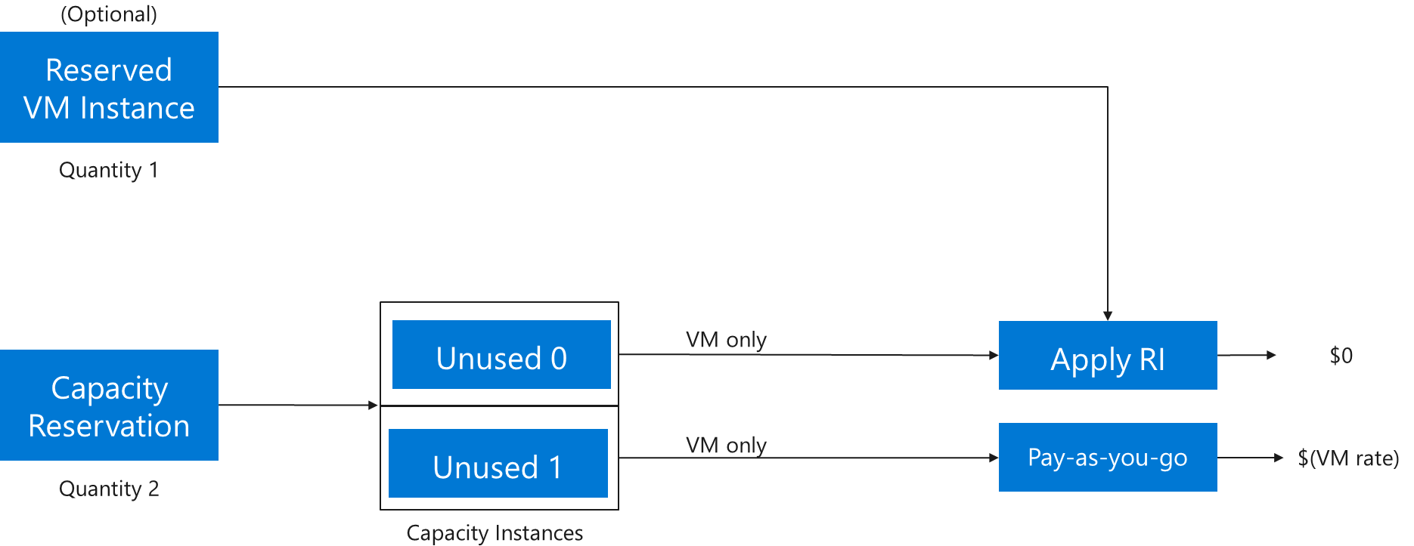

In the above picture, VM Reserved Instance discount is applied to one of the unused instances and the cost for that instance will be zeroed out. For the other instance, PAYG rate will be charged for the VM size reserved.
When a VM is allocated against the Capacity Reservation, the additional VM components (disks, network, extensions, and any other requested components) must also be allocated. In this state, the usage will reflect one allocated VM and one unused capacity instance. The Reserved VM Instance will zero out the cost of either the VM or the unused capacity instance. The other charges for disks, networking etc. associated with the allocated VM will also appear on the bill. Here is an example:

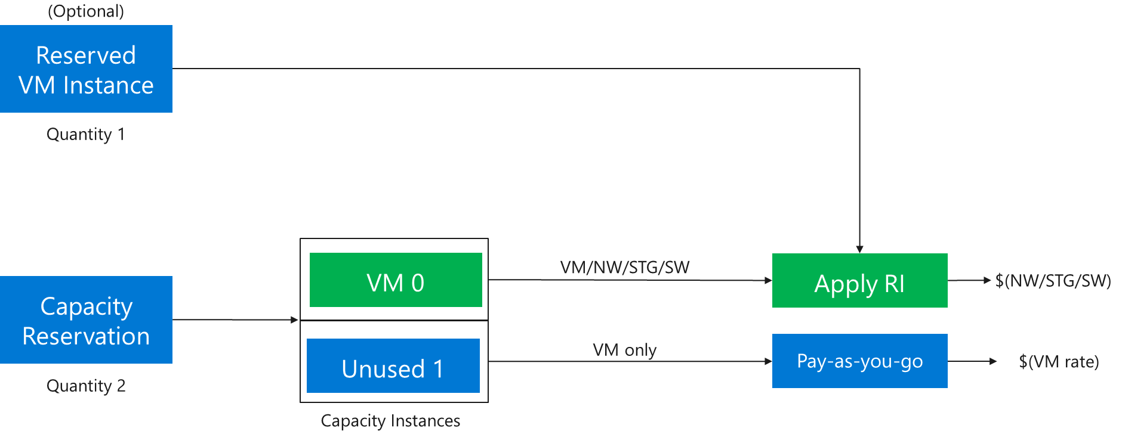

As show in the picture above, VM Reserved Instance discount is applied to VM 0 and for that VM, the customer is only being charged for other components such as disk, networking etc. The other unused instance is being charged at PAYG rate for the VM size reserved.

Capacity Reservation in “Failed” provisioning State
It is possible, in a very rare circumstances, that an existing Capacity Reservation goes into a “Failed” provisioning state due to a system error or due to a customer-initiated action such as modifying the quantity reserved. In most cases, just retrying should fix the issue. However, in case the Capacity Reservation goes into the “Failed” provisioning state as a result of increasing the quantity reserved, just retrying may not fix the issue. In this situation, follow the steps below to restore the reservation:
Steps:
- Go to the Application Change Analysis screen on Azure portal.
- From the filters at the top of the page, select subscription, resource group, and time range. Please note that you can only go back up to 14 days in the past.
- In the search box, type in the name of the capacity reservation and look for the change in “sku.capacity” property for that reservation. Find out the original quantity reserved which will be the value under the “Old Value” column.

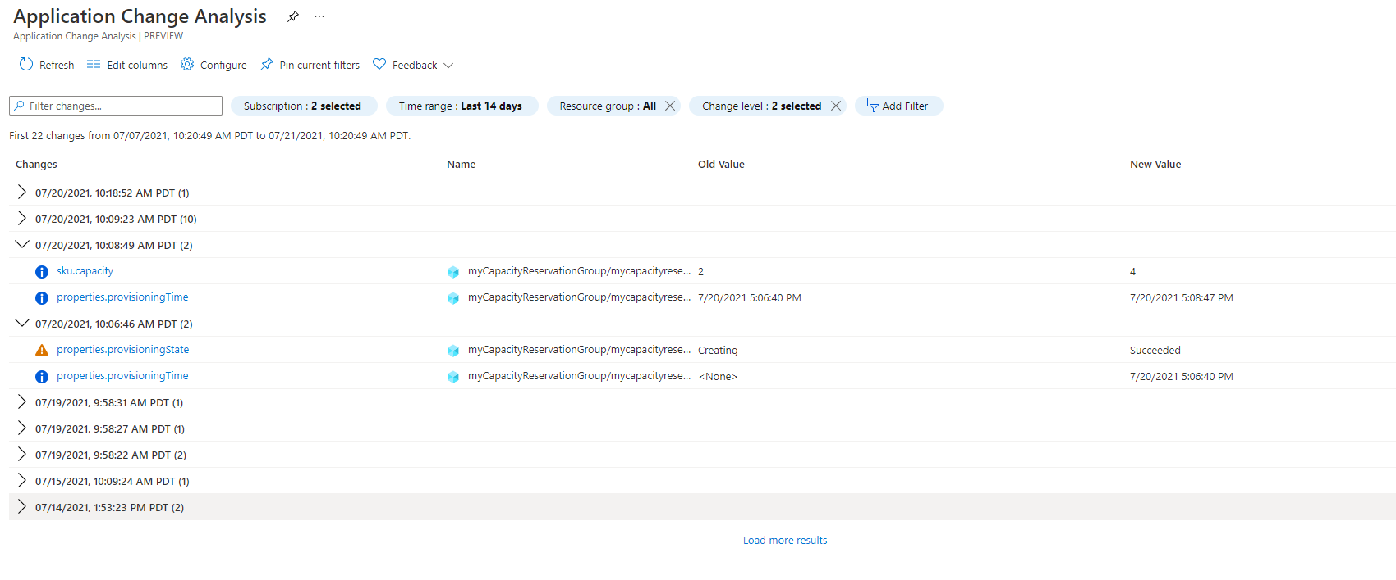
4. Update capacity reservation to the old quantity reserved by following the steps detailed here. Once updated, the reservation should be available immediately for use with virtual machines.

If capacity reservation is still in failed provisioning state after taking the steps above, please create a support ticket.

